REFLECTION IN CONCAVE MIRROR

- SET UPS :

- Object Position : Between F and P
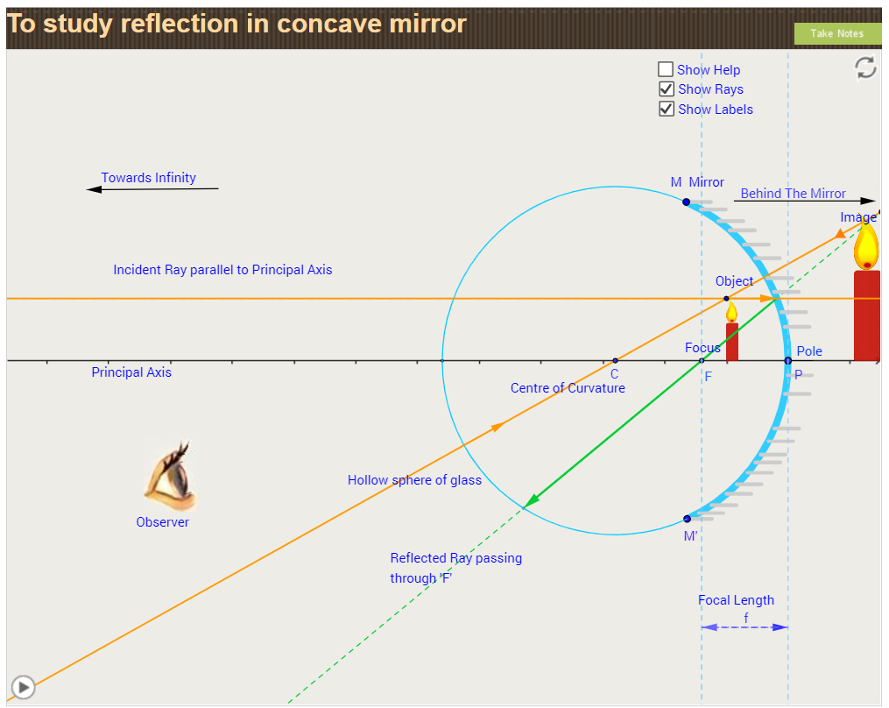

- Object Position : At focus, F

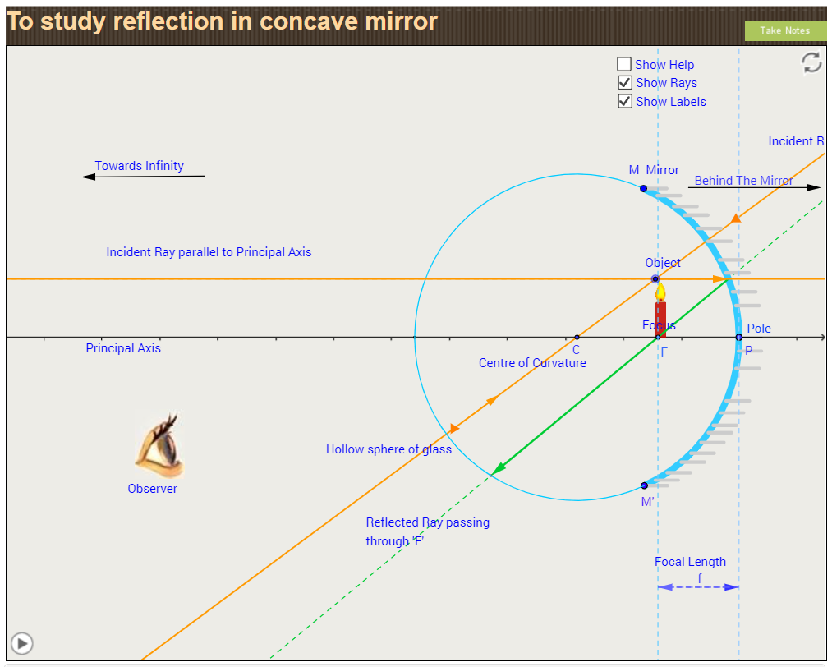

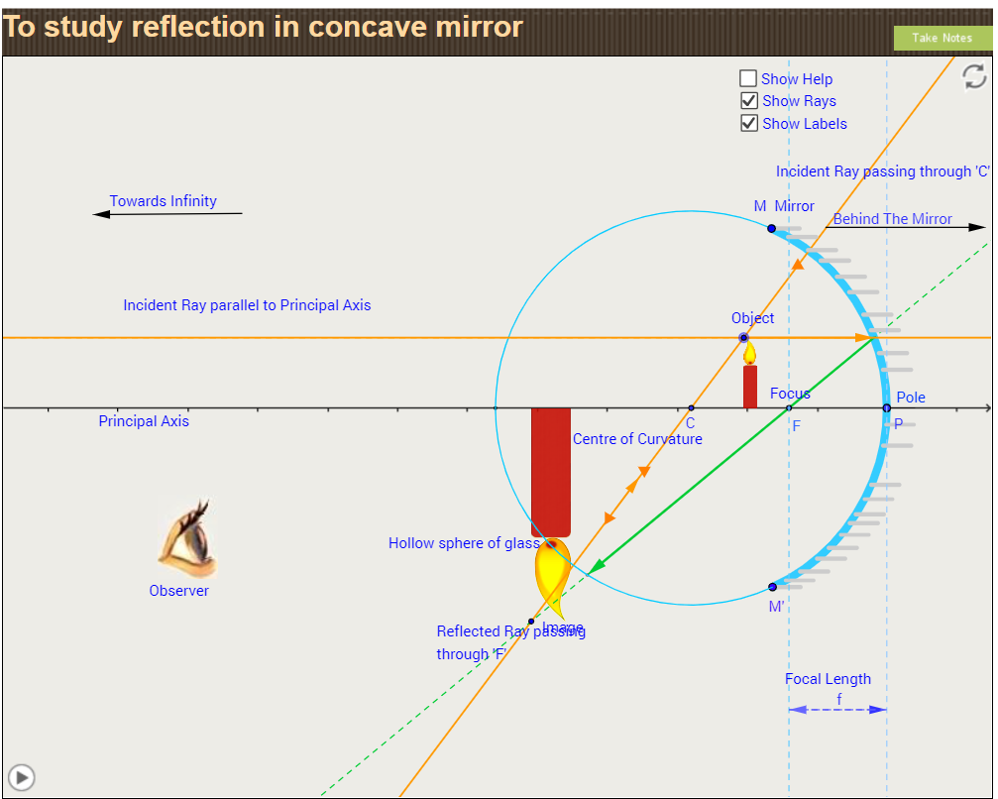
- Object Position : Between F and C

- Object Position: At C
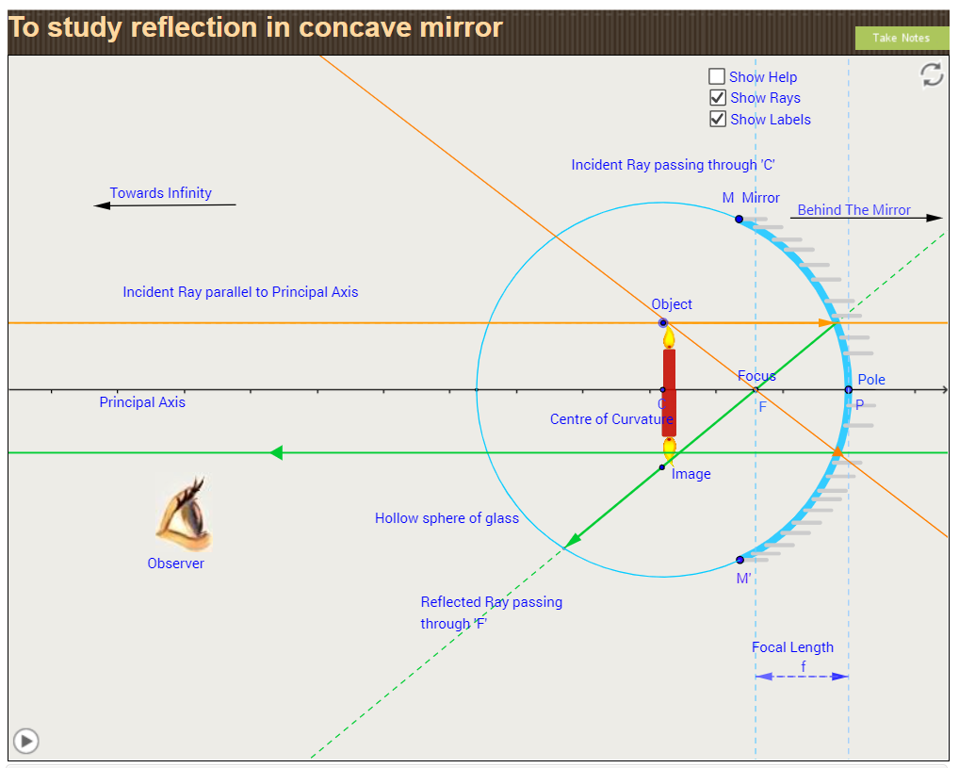

- Object Position: Beyond C
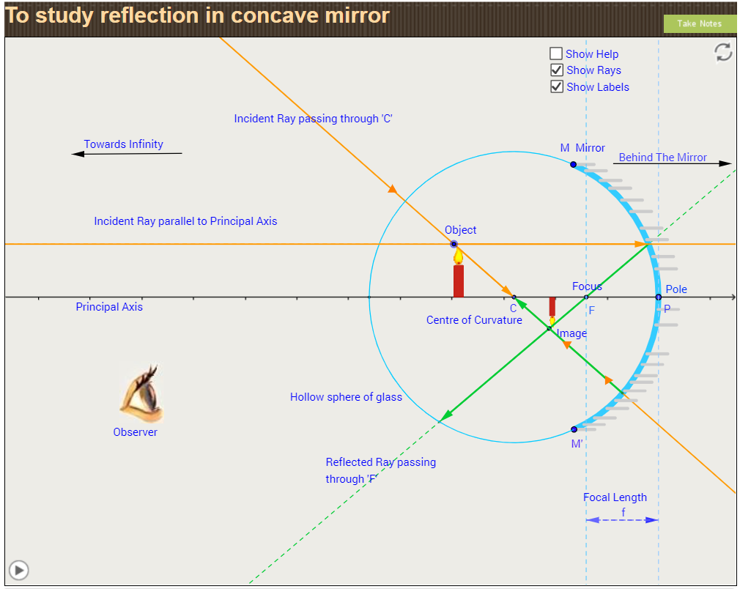

- Observation Table:

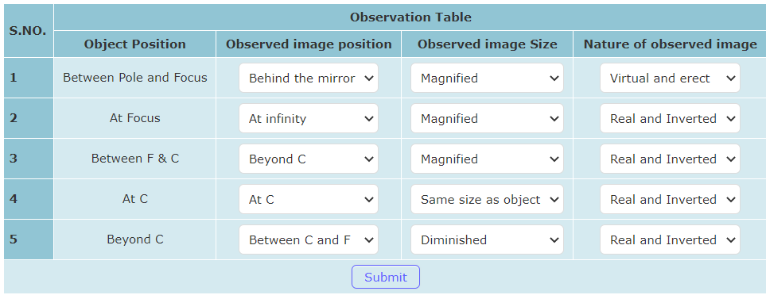

- Observation Table Corrected:

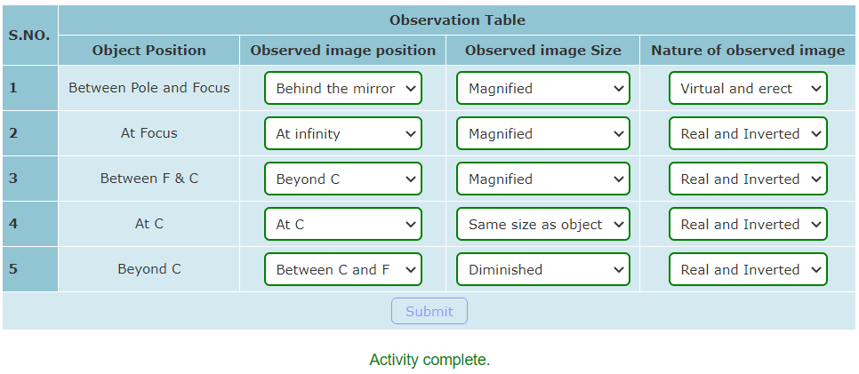
By: Nidhi Sarah Johnson
Class 10C
JSSPS

