Experiment No.3
Date: 5/10/2020

Observation:
Sample No | Litmus Test | With Zinc dust | With Phenolphthalein | Inference
 | Changes to | Hydrogen gas is evolved and burns with a pop sound /No gas evolution |  | The given Sample is acid/base
1 | Red  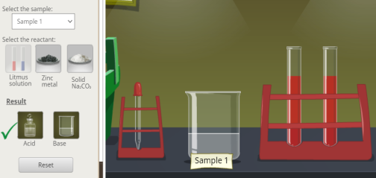 | 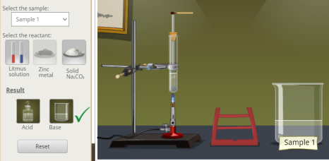  Hydrogen gas is evolved and burns with a pop sound |  | The given Sample is an acid.
3 | Blue  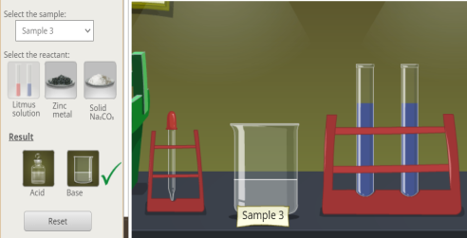 | Hydrogen gas is evolved and burns with a pop sound  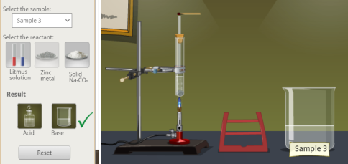 |  | The given Sample is a base.
5 | Red  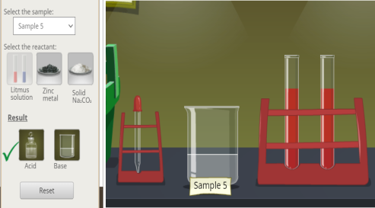 | Hydrogen gas is evolved and burns with a pop sound  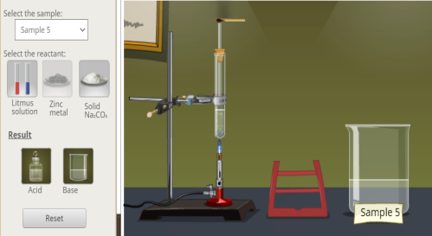 |  | The given Sample is an acid.
7 | Red  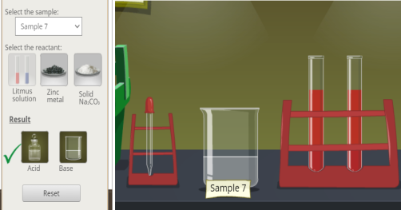 | Hydrogen gas is evolved and burns with a pop sound  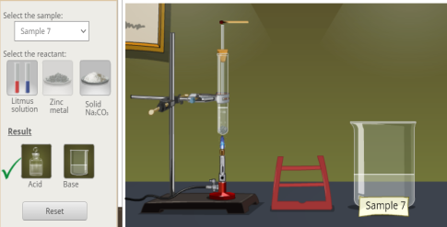 |  | The given Sample is an acid.

